# K:\naac report\Website Saurav\web selected\college logo.jpg

# Sant Gadge Baba Amravati university Amravati affiliated

People’s Welfare Society, Amravati’s

**Late Narayanrao Amrutrao Deshmukh Arts and Commerce College Chandur Bazar, Distt. Amravati**

# Accredited by NAAC at “B” Level

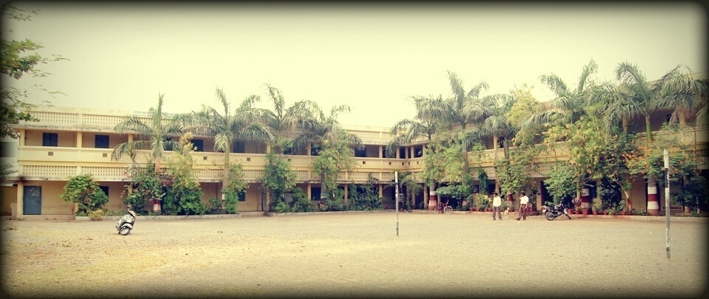

# The Annual Quality Assurance Report (AQAR) of the IQAC

For the Academic Year-**2013-14**

(From July 1, 2013 to June 30, 2014)

Submitted to

**National Assessment and Accreditation Council**

**Bangalore**

# The Annual Quality Assurance Report (AQAR) of the IQAC

**Of**

People’s Welfare Society, Amravati’s

**Late Narayanrao Amrutrao Deshmukh Arts and Commerce College Chandur Bazar, Distt. Amravati**

# Affiliated to

# Sant Gadge Baba Amravati university Amravati (M.S.)

For the Academic Year-**2013-14**

(From July 1,2013 to June 30, 2014)

**Part – A**

**1. Details of the Institution**

**People’s Welfare Society Amravati’s**

**Late Narayanrao Amrutrao Deshmukh Arts and Commerce College, Chandur Bazar, Distt. Amravati (M.S.) PIN-444704**

1.1 Name of the Institution

Nangaliya Nagar, Chandur Bazar, Distt. Amravati PIN-444704

1.2 Address Line 1

Address Line 2

Chandur Bazar

City/Town

Maharashtra

State

444704

Pin Code

Institution e-mail address

[nadm143@yahoo.com](mailto:nadm143@yahoo.com)

07227 244479

Contact Nos.

**Principal Dr. V.D. Chore**

Name of the Head of the Institution:

07227 244479

Tel. No. with STD Code:

Mobile:

9730067400

**Asstt. Prof. Manoj P. Sahare**

Name of the IQAC Co-ordinator:

+919420417541

Mobile:

[nadm143@yahoo.com](mailto:nadm143@yahoo.com)

mpsaharenad@gmail.com

IQAC e-mail address:

**MHCOGN11054**

1.3 **NAAC Track ID**

1.4 **NAAC Executive Committee No. & Date:**

***Dated 3-5-2004.***

www.nadmchb.org

1.5 Website address:

[www.nadmchb.org/NAAC/AQAR](http://www.nadmchb.org/NAAC/AQAR)/2013-14.doc.

Web-link of the AQAR:

1.6 Accreditation Details

|  |  |  |  |  |  |
| --- | --- | --- | --- | --- | --- |
| Sl. No. | Cycle | Grade | CGPA | Year of Accreditation | Validity Period |
| 1 | 1st Cycle | B | --- | 2004 | 5 yrs. |
| 2 | 2nd Cycle |  |  |  |  |

**10/07/2004**

1.7 Date of Establishment of IQAC: DD/MM/YYYY

**2013-14**

**1.8 AQAR for the year**

1.9 Details of the previous year’s AQAR submitted to NAAC after the latest Assessment and Accreditation by NAAC

1. AQAR- 2009-10 submitted to NAAC by post
2. AQAR- 2010-11 submitted to NAAC on 17/10/2014 via Mail
3. AQAR- 2011-12 submitted to NAAC on 22/10/2014 via Mail
4. AQAR- 2012-13 submitted to NAAC on 22/10/2014 via Mail

1.10 Institutional Status

**🗸**

University State Central Deemed Private

**🗸**

Affiliated College Yes No

Constituent College Yes No

**🗸**

Autonomous college of UGC Yes No

**🗸**

**🗸**

Regulatory Agency approved Institution Yes No

(e.g., AICTE, BCI, MCI, PCI, NCI)

**🗸**

Type of Institution Co-education Men Women

**🗸**

Urban Rural Tribal

**🗸**

**🗸**

**🗸**

Financial Status Grant-in-aid UGC 2(f) UGC 12B

Grant-in-aid + Self Financing Totally Self-financing

**🗸**

1.11 Type of Faculty/Programme

**🗸**

**🗸**

Arts Science Commerce Law PEI (Phys Edu)

TEI (Edu) Engineering Health Science Management

Others (Specify)

    ------

Sant Gadge Baba Amravati University, Amravati (Maharashtra)

1.12 Name of the Affiliating University *(for the College*

1.13 Special status conferred by Central/ State Government--UGC/CSIR/DST/DBT/ICMR etc.

Autonomy by State/Central Govt. / University

-----

---------

University with Potential for Excellence UGC-CPE

---------

-----

-------

DST Star Scheme UGC-CE

--------

---------

UGC-Special Assistance Programme DST-FIST

-----------

UGC-Innovative PG programmes Any other (*Specify*)

-------

UGC-COP Programmes

---------

**2. IQAC Composition and Activities**

2.1 No. of Teachers

07

2.2 No. of Administrative/Technical staff

02

2.3 No. of students

-------

2.4 No. of Management representatives

-------

01

2.5 No. of Alumni

2. 6 No. of any other stakeholder and

01

Community representatives

--------

2.7 No. of Employers/ Industrialists

-------

2.8 No. of other External Experts

2.9 Total No. of members

03

11

2.10 No. of IQAC meetings held

2.11 No. of meetings with various stakeholders

03

No. Faculty

03

----

Non-Teaching Staff Students Alumni Others

-----

**🗸**

2.12 Has IQAC received any funding from UGC during the year? Yes No

-----------

If yes, mention the amount

2.13Seminars and Conferences (only quality related)

(i) No. of Seminars/Conferences/ Workshops/Symposia organized by the IQAC

Total Nos. Level International National State Institution

-------------

---

----

------

----------

----------

(ii) Themes

2.14 Significant Activities and contributions made by IQAC

* Feedback regarding the quality of teaching and availability of facilities was obtained from students in prescribed proforma.
* IQAC plays an important role in helping the administration & various committees of the college.
* Imparting suggestions for activities & suggestions for maintaining the quality of education as per the guidelines by NAAC
* Monitoring academic, co-curricular activities including teaching-learning evaluations.

2.15 Plan of Action by IQAC/Outcome

The IQAC chalks out its plan of action in according with that of the Annual Planning Committee. The IQAC analyses the achievement of the plan of action chalked out by the IQAC and Annual Planning Committee in the beginning of the year towards quality enhancement. The following table shows the plan of action and its achievements.

|  |  |
| --- | --- |
| **Plan of Action** | **Achievements** |
| 1) To conduct the meeting of IQAC.  2) To make the efforts for beautification of campus.  3) To enrich Library & Laboratories.  4) To motivate the teachers to undertake research.  5) To encourage the students for  Building their overall development.  7) To promote student-centred activities through various programmes  8) To encourage students for creative writing.  9) To maintain biometric system.  10) To organize National Conference. | 1) Conducted 3 meetings of IQAC in a year.  2) Plant watering done by students.  3) Purchased new books, periodicals, reference books, as per requirement.  4) Almost all faculties published research articles/papers at various levels. Some of the faculty members presented papers in State,  National and International Conferences/seminars.  Some of the Faculty members published papers in  National & International Journals.  5) Many students have shown outstanding performances in sports at University and State level.  7) The students participated in the College Annual Gathering, NSS Camp, Participation in University Youth Festival and other programmes.  8) The students contributed their essays, short stories, and poems in the College Annual “NAD”.  9) Biometric system was maintained.  10) National conference was organized by the Department of Economics. |

*\* The Academic Calendar of the year is attached as Annexure.*

🗸

2.15 Whether the AQAR was placed in statutory body Yes No

🗸

Management Syndicate Any other body

Provide the details of the action taken

After going through all the details of AQAR, The Management of the college approved the same and granted permission to submit the AQAR to NAAC.

**Part – B**

**Part-B**

**Criterion – I**

**1. Curricular Aspects**

1.1 Details about Academic Programmes

|  |  |  |  |  |
| --- | --- | --- | --- | --- |
| Level of the Programme | Number of existing Programmes | Number of programmes added during the year | Number of self-financing programmes | Number of value added / Career Oriented programmes |
| PhD | --- | --- | --- | --- |
| PG | --- | --- | 01 | --- |
| UG | 01 | --- | 01 | --- |
| PG Diploma | --- | --- | --- | --- |
| Advanced Diploma | --- | --- | --- | --- |
| Diploma | --- | --- | --- | --- |
| Certificate | --- | --- | --- | --- |
| Others | --- | --- | ---- | --- |
| **Total** | 01 | --- | 02 | --- |

|  |  |  |  |  |
| --- | --- | --- | --- | --- |
| Interdisciplinary | --- | --- | --- | --- |
| Innovative | --- | --- | --- | --- |

1.2 (i) Flexibility of the Curriculum: CBCS/Core/Elective option / Open options

(ii) Pattern of programmes:

|  |  |
| --- | --- |
| Pattern | Number of programmes |
| Semester | 1 |  |  |  |
| Trimester | --- |
| Annual | 2 |

🗸

🗸

🗸

1.3 Feedback from stakeholders* Alumni Parents Employers students

***(On all aspects)***

🗸

Mode of feedback : Online Manual Co-operating schools (for PEI)

***\* The analysis of the feedback is attached as an Annexure***

1.4 Whether there is any revision/update of regulation or syllabi, if yes, mention their salient aspects.

There is no revision of syllabi during this year. The syllabi and regulations are followed as per the directions by Sant Gadge Baba Amravati University.

1.5 Any new Department/Centre introduced during the year. If yes, give details.

-----------

**Criterion – II**

**2. Teaching, Learning and Evaluation**

|  |  |  |  |  |
| --- | --- | --- | --- | --- |
| Total | Asst. Professors | Associate Professors | Professors | Others |
| 12 | 06 | 03 | Principal-01 | 02 |

2.1 Total No. of permanent faculty

05

2.2 No. of permanent faculty with Ph.D.

|  |  |  |  |  |  |  |  |  |  |
| --- | --- | --- | --- | --- | --- | --- | --- | --- | --- |
| Asst. Professors | | Associate Professors | | Professors | | Others | | Total | |
| R | V | R | V | R | V | R | V | R | V |
| -- | -- | --- | --- | --- | -- | -- | -- | 00 | 00 |

2.3 No. of Faculty Positions Recruited (R) and Vacant (V) during the year

2.4 No. of Guest and Visiting faculty and Temporary faculty

11

2.5 Faculty participation in conferences and symposia:

|  |  |  |  |
| --- | --- | --- | --- |
| No. of Faculty | International level | National level | State level |
| Attended Seminars/ Workshops | 11 | 35 | 06 |
| Presented papers | 11 | 35 | 6 |
| Resource Persons | ---- | 02 | 01 |

2.6 Innovative processes adopted by the institution in Teaching and Learning:

* Model, Chart and Diagram are used during teaching.
* Subject wise Unit tests are conducted.
* Educational Excursions and Class Seminars.

2.7 Total No. of actual teaching days

183

during this academic year

2.8 Examination/ Evaluation Reforms initiated by

Open Book Examination

the Institution (for example: Open Book Examination, Bar Coding,

Double Valuation, Photocopy, Online Multiple Choice Questions)

2.9 No. of faculty members involved in curriculum

02 faculties are on Board of Studies.

restructuring/revision/syllabus development

as member of Board of Study/Faculty

/Curriculum Developmen workshop

85%

2.10 Average percentage of attendance of students

2.11 Course/Programme wise distribution of pass percentage:

|  |  |  |  |  |  |  |
| --- | --- | --- | --- | --- | --- | --- |
| Title of the Programme | Total no. of students appeared | Division | | | | |
| Distinction % | I % | II % | III % | Pass % |
| B.A. | 124 | ------ | 13.70 | 29.03 | 8.06 | 50.81 |
| B.C.A. | 11 | ----- | 11.11 | 00 | 33.33 | 44.44 |
| M.A. | 15 | ------ | 62.50 | 6.25 | 25.00 | 93.75 |

2.12 How does IQAC Contribute/Monitor/Evaluate the Teaching & Learning processes:

IQAC is nodal agency of the institution. It keeps an eye on the process of teaching learning activities. It coordinates the quality related activities by adopting and disseminating the best practices for overall development of the college in particular and of the students in general. It maintains the institutional database obtained through feedback and through MIS for the purpose of maintaining and enhancing the quality culture in the institution.

IQAC evaluates the teaching and learning process adopting the following parameters:

* Analysing the Student’s Feedback on teaching and curriculum.
* Analysing the performance of students in Unit test and Assignments conducted throughout the year.
* Analysing students’ exam performance in rank/merit order.
* Analysing the API and PBAS of the faculty.
* Collecting the data of research performance of the faculties and analyzing the same.

2.13 Initiatives undertaken towards faculty development

|  |  |
| --- | --- |
| *Faculty / Staff Development Programmes* | *Number of faculty benefitted* |
| Refresher courses | 2 |
| UGC – Faculty Improvement Programme | - |
| HRD programmes | - |
| Orientation programmes | 01 |
| Faculty exchange programme | - |
| Staff training conducted by the university | - |
| Staff training conducted by other institutions | - |
| Summer / Winter schools, Workshops, etc. | - |
| Others | 1 |

2.14 Details of Administrative and Technical staff

|  |  |  |  |  |
| --- | --- | --- | --- | --- |
| Category | Number of Permanent  Employees | Number of Vacant  Positions | Number of permanent positions filled during the Year | Number of positions filled temporarily |
| Administrative Staff | 04+04=08 | 00 | 00 | 02 |
| Technical Staff | 00 | 00 | 00 | 00 |

**Criterion – III**

**3. Research, Consultancy and Extension**

3.1 Initiatives of the IQAC in Sensitizing/Promoting Research Climate in the institution

* IQAC of the institution inspires the fellow teachers to prepare research projects, research papers and participate in National and International seminars/symposia, etc.
* IQAC of the institution also assists in preparing research proposals of individual staff members and forward them to various funding agencies.
* Many faculty members actively participated, presented papers at various National and State Level Conferences and Seminars. Most of them are actively engaged in publishing research papers and books.
* The IQAC and the Principal have always encouraged and facilitated the faculties to pursue Research Work.
* As a result of promoting research climate, at present there are 5 faculties with Ph.D. They are Dr. A.N. Bhorjar in History, Dr. A.K. Khadse in Marathi and Prof Ku. J.S. Ingole in Geography. Dr.V.D. Chore in Economics and Dr. P.A. Raut in political science were awarded with Ph.D in 2013-14.
* Prof. Ku. Neena Chaware in Home-Economics, Prof. R.B. Pawar in Marathi and Prof. A.S. Vaidya are pursuing Ph.D.
* Dr. A.N. Bhorjar is working as a Ph.D. guide under whom 6 students are doing Ph. D. Work in History. Five of his students were awarded with Ph.D. so far.
* Dr. Jayshree Ingole is working as Ph.D.guide under whom 3 students are doing Ph. D. Work in Geography.
* Dr. A.N. Bhorjar has been appointed as an Expert on Ph.D. Viva panel.
* The principal grants D.L.s to faculties whenever necessary for research work.
* Minor Research Projects are being undertaken by 4 faculties during the year. They are Prof. Dr. Ku. Jayshree Ingole, Dr.A.N.Bhorjar, Prof. Anil S. Vaidya and Librarian Prof. Ku. Meena Lakade. They are working on their Minor research Projects.
* A research journal - ‘NAD - A Journal of Research ’was started by the college. Dr.V.D.Chore is the editor of this journal
* A national coferance was organiosed in economics on 22nd, 23rd & 24th November 2013. Conference proceedings “Arthnaad” with ISSN was also published in this conference.

3.2Details regarding major projects

|  |  |  |  |  |
| --- | --- | --- | --- | --- |
|  | Completed | Ongoing | Sanctioned | Submitted |
| Number | ----- | ---- |  |  |
| Outlay in Rs. Lakhs | ----- | ----- |  |  |

3.3 Details regarding minor projects

|  |  |  |  |  |
| --- | --- | --- | --- | --- |
|  | Completed | Ongoing | Sanctioned | Submitted |
| Number | ------ | 04 | ------- | ----- |
| Outlay in Rs. Lakhs  Dr. A.N. Bhorjar  Prof.Ku.Meena Lakde  Dr. Jayshree Ingole  Prof. A.S. Vaidya |  | Rs.100000/-  Rs.85000/-  Rs.80000/-  Rs.85000 |  |  |

3.4 Details on research publications

|  |  |  |  |
| --- | --- | --- | --- |
|  | International | National | Others |
| Peer Review Journals | ----- | ---- | ---- |
| Non-Peer Review Journals | 2 | ---- | ----- |
| e-Journals | ---- | ----- | --- |
| Conference proceedings | ---- | 1 | --- |

3.5 Details on Impact factor of publications:

✓

Range Average h-index Nos. in SCOPUS

3.6 Research funds sanctioned and received from various funding agencies, industry and other organisations

|  |  |  |  |  |
| --- | --- | --- | --- | --- |
| Nature of the Project | Duration  Year | Name of the  funding Agency | Total grant  sanctioned | Received |
| Major projects | --- | --- | --- | --- |
| Minor Projects | 2011-12 | WRO-UGC | 350000 | 270000 |
| Interdisciplinary Projects | --- | --- | --- | --- |
| Industry sponsored | --- | --- | --- | --- |
| Projects sponsored by the University/ College | --- | --- | --- | --- |
| Students research projects  *(other than compulsory by the University)* | ---- | --- | -- | -- |
| Any other(Specify) | --- | -- | -- | -- |
| Total | 2011-12 | WRO-UGC | 350000 | 270000 |

3.7 No. of books published i) With ISBN No. Chapters in Edited Books

--

1

ii) Without ISBN No.

3.8 No. of University Departments receiving funds from

--

UGC-SAP CAS DST-FIST

--

--

--

--

DPE DBT Scheme/funds

3.9 For colleges Autonomy CPE DBT Star Scheme

--

--

--

INSPIRE CE Any Other (specify)

--

--

--

----

3.10 Revenue generated through consultancy

|  |  |  |  |  |  |
| --- | --- | --- | --- | --- | --- |
| Level | International | National | State | University | College |
| Number | -- | 1 | -- | -- | -- |
| Sponsoring agencies |  | ICSSR &UGC |  |  |  |

3.11 No. of conferences organized by the Institution

03

3.12 No. of faculty served as experts, chairpersons or resource persons

--

--

1

3.13 No. of collaborations International National Any other

--

3.14 No. of linkages created during this year

3.15 Total budget for research for current year in lakhs: 1.70

ICSSR- 100000

70000

From Funding agency From Management of University/College

Rs.170000/-

Total

3.16 No. Of patents received this year

|  |  |  |
| --- | --- | --- |
| Type of Patent |  | Number |
| National | Applied | -- |
| Granted |  |
| International | Applied | -- |
| Granted |  |
| Commercialised | Applied | -- |
| Granted |  |

3.17 No. of research awards/ recognitions received by faculty and research fellows

|  |  |  |  |  |  |  |
| --- | --- | --- | --- | --- | --- | --- |
| Total | International | National | State | University | Dist | College |
| 01 |  | 01-Best Research paper |  |  |  |  |

Of the institute in the year

3.18 No. of faculty from the Institution

02

who are Ph. D. Guides

13

and students registered under them

3.19 No. of Ph.D. awarded by faculty from the Institution

01

3.20 No. of Research scholars receiving the Fellowships (Newly enrolled + existing ones)

--

--

JRF SR Project Fellows Any other

---

--

3.21 No. of students Participated in NSS events:

02

--

University level State level

National level International level

--

--

3.22 No. of students participated in NCC events:

--

--

University level State level

National level International level

--

--

3.23 No. of Awards won in NSS: University level State level

--

--

National level International level

--

---

3.24 No. of Awards won in NCC: University level State level

--

--

National level International level

--

--

3.25 No. of Extension activities organized

17

----

University forum College forum

02

10

---

NCC NSS Any other

3.26 Major Activities during the year in the sphere of extension activities and Institutional Social Responsibility

The institution organized various extension activities during the academic year 2013-14.

* A workshop on Soyabean Product was conducted by the department of Home-Economics.
* Tribute to Martyr was offered to the officers who sacrificed themselves in 26/11 Terrorist attack on Mumbai.
* AIDS Awareness rally was organized in the town under AIDS Awareness Week.
* Geography day was celebrated in the college by the Department of geography.
* Elocution Competition was organized by the NSS Unit.
* As a Public Awareness Drive, street plays were performed by NSS Volunteers at Borala where NSS Camp was organized.
* Educational Excursions were organized by the Department of Geography and the Department of History.
* Alumni Meet was organized in the conference Hall of the college.
* National Conference on “Impact of FDI & Retail Sector” by the Department of Economics sponsored by ICSSR.
* 29 students participated in youth festival organized by Sant Gadge Baba Amravati University Amravati.
* Students participated in sports and games event organized by Sant Gadge Baba Amravati University Amravati and four students bagged colour coat for participation in the University Team of sports.
* The College celebrated various days, the birth and death anniversaries of national heroes and social workers such as Shivaji Maharaj, Mahatma Gandhi, Shau Maharaj, Dr. Ambedkar, Mahatma Jyotiba Phule, Saint Gadage Baba, Vivekananda, Dr. Panjabrao Deshmukh etc.

**Criterion – IV**

**4. Infrastructure and Learning Resources**

4.1 Details of increase in infrastructure facilities:

|  |  |  |  |  |
| --- | --- | --- | --- | --- |
| Facilities | Existing | Newly created | Source of Fund | Total |
| Campus area | 1.5 Acre  +4 Acres |  | Parent Society | 5.5 Acres |
| Class rooms | 08 | ---- |  | 08 |
| Laboratories | 04 | -- |  | 04 |
| Seminar Halls | 01 | -- |  | 01 |
| No. of important equipments purchased (≥ 1-0 lakh) during the current year. | 26 | - | UGC | 26 |
| Value of the equipment purchased during the year (Rs. in Lakhs) | 6.24 | ---- | UGC | 6.24 |
| Others | --- | --- | -- | --- |

4.2 Computerization of administration and library

Admissions process was performed in the beginning of the year as per the directions by the University. The list of students admitted has been maintained in computerized mode. Scholarships, Salary account are maintained through Computerization.

4.3 Library services:

|  |  |  |  |  |  |  |
| --- | --- | --- | --- | --- | --- | --- |
|  | Existing | | Newly added | | Total | |
| No. | Value | No. | Value | No. | Value |
| Text Books | 5560 | Rs.1503849/- | ---- | ---- | 5560 | Rs.1503849/- |
| Reference Books | 739 | Rs.581735/- | 163 | Rs. 42983/- | 902 | Rs. 624718/- |
| e-Books |  |  |  |  |  |  |
| Journals |  |  |  |  |  |  |
| e-Journals |  |  |  |  |  |  |
| Digital Database |  |  |  |  |  |  |
| CD & Video |  |  |  |  |  |  |
| Others (specify) |  |  |  |  |  |  |

4.4 Technology up gradation (overall)

|  |  |  |  |  |  |  |  |  |
| --- | --- | --- | --- | --- | --- | --- | --- | --- |
|  | Total Computers | Computer Labs | Internet | Browsing Centres | Computer Centres | Office | Depart-ments | Others |
| Existing | 26 | 01 | 01 | 10 | -- | 01 | 01 | --- |
| Added | --- | --- | ---- | -- | ----- | --- | ---- | --- |
| Total | 26 | 01 | 01 | 10 | -- | 01 | 01 | -- |

4.5 Computer, Internet access, training to teachers and students and any other programme for technology up-gradation (Networking, e-Governance etc.)

The B.C.A. stream has Computer Laboratory. Computer lab provides excellent academic computing facilities to the faculty and students. The Faculty members utilize the services of internet for their research activities. Students are advised to avail the internet services provided in the Computer laboratory.

4.6 Amount spent on maintenance in Lakh:

0.20

i) ICT

1

ii) Campus Infrastructure and facilities

0.10

iii) Equipments

0.09

iv) Others

1.39

**Total:**

**Criterion – V**

**5. Student Support and Progression**

5.1 Contribution of IQAC in enhancing awareness about Student Support Services

The college runs various internal committees for student support. The IQAC helps and provides every possible facility to committees constituted for the progress of students. The IQAC works in collaboration the various committees function in the college for student support.

5.2 Efforts made by the institution for tracking the progression

The IQAC works in collaboration with College Council. The College council constitutes various committees at the beginning of academic session. The committees conducted various programmes for the betterment of students. The college council takes feedback of all committees and maintained records of the activities done by committees.

|  |  |  |  |
| --- | --- | --- | --- |
| UG | PG | Ph. D. | Others |
| 553 | 29 | --- | -- |

5.3 (a) Total Number of students

(b) No. of students outside the state

---

(c) No. of international students

----

|  |  |
| --- | --- |
| No | % |
| 226 | 38.83% |

|  |  |
| --- | --- |
| No | % |
| 356 | 61.16% |

Men Women

|  |  |  |  |  |  |  |  |  |  |  |  |
| --- | --- | --- | --- | --- | --- | --- | --- | --- | --- | --- | --- |
| Last Year | | | | | | This Year | | | | | |
| General | SC | ST | OBC | Physically Challenged | Total | General | SC | ST | OBC | Physically Challenged | Total |
| 36 | 112 | 10 | 462 | -- | 620 | 88 | 130 | 11 | 353 | -- | 582 |

Demand ratio- 1:1

Dropout%- B.A.- 49.79%; B.C.A- 25.00%; M.A.- 5.88%

5.4 Details of student support mechanism for coaching for competitive examinations (If any)

1. Career Guidance Cell is functioning in the college.
2. Useful information about UPSC and MPSC and other competitive examinations was given to the students

----

No. of students beneficiaries

5.5 No. of students qualified in these examinations

---

--

--

2

NET SET/SLET GATE CAT

IAS/IPS etc State PSC UPSC Others

-04

--

--

5.6 Details of student counselling and career guidance

* The college has a Career Guidance and Placement Cell, a committee of teachers has been appointed for this purpose.
* A committee of teachers provides academic and personal counselling.
* Students were advised to appear in competitive exams like MPSC/Bank Recruitment/SSC etc.

10

No. of students benefitted

5.7 Details of campus placement

|  |  |  |  |
| --- | --- | --- | --- |
| ***On campus*** | | | ***Off Campus*** |
| Number of Organizations Visited | Number of Students Participated | Number of Students Placed | Number of Students Placed |
| --- | --- | --- | 02 |

5.8 Details of gender sensitization programmes

* Friendly atmosphere is always maintained to create healthy and secure atmosphere for girls students
* Save Girl- Save Earth rally was organised in the adopted village by NSS Unit.

5.9 Students Activities

5.9.1 No. of students participated in Sports, Games and other events

33

--

--

State/ University level National level International level

No. of students participated in cultural events

--

--

29

State/ University level National level International level

5.9.2 No. of medals /awards won by students in Sports, Games and other events

----

04

----

Sports: State/ University level National level International level

-----

-----

-------

Cultural: State/ University level National level International level

5.10 Scholarships and Financial Support

|  |  |  |
| --- | --- | --- |
|  | Number of  students | Amount |
| Financial support from institution | --- | ---- |
| Financial support from government (GOI) | 481 | Rs.883175/- |
| Financial support from other sources | --- | ---- |
| Number of students who received International/ National recognitions | --- | ---- |

5.11 Student organised / initiatives

--

--

--

Fair : State/ University level National level International level

--

Exhibition: State/ University level National level International level

--

--

01

5.12 No. of social initiatives undertaken by the students

5.13 Major grievances of students (if any) redressed: Student Grievances and Redressal Committee is functional in the college. The committee looks into the matter of complaint made by students if any.

**Criterion – VI**

**6. Governance, Leadership and Management**

6.1 State the Vision and Mission of the institution

**MISSION STATEMENT:**

“Let’s strive for the realization of the goals dreamt by Mahatma Gandhi as he says that “When I was looking at rural masses, I was looking far beyond”. In search of the same truth this college stands for ‘Dnyan and Vidnyan upasana’, which leads to the light of knowledge and to the growth of a culture bound to usher in an era of peace, harmony, and prosperity for the society.”

**Aims & Objectives:**

1. The all-round development of the students aspiring to be a learned and cultured citizen, by giving them opportunities to face challenges of the competitive world with utmost utilization of their acquired knowledge, skills, potentials in academics, sports and culture.
2. To provide the facilities of higher education to those who want to acquire higher education, especially to the students from rural strata at minimum expenses.
3. To plan and execute various schemes for the development of hidden potential in student community.
4. To create a feeling of affinity towards rural society and rural way of life in student community.
5. To create educational, social and cultural sense among the students.
6. To cultivate a sense of social service, social welfare and equality in the student community
7. To work for the growth of a sense of duty, service, nationalism and secularism in the student community.

6.2 Does the Institution has a management Information System

Yes.

* The institution uploaded the college data of Academic Year-2013-14 on Management Information System of Director of Higher Education, Pune, Maharashtra Government.
* DCF-II of the college for 2013-14 was uploaded on the Portal, i.e., www.aishe.gov.in

6.3 Quality improvement strategies adopted by the institution for each of the following:

6.3.1 Curriculum Development

* Lectures and Practicals are conducted according to SGB University/UGC guidelines.
* Tutorials are conducted as per the norms by The University.
* Faculty members actively participate in Syllabus framing workshops conducted by the university.
* The college and the faculties adopt and execute the changes made in the syllabi from time to time.

6.3.2 Teaching and Learning

* Lectures, practicals & tutorials are conducted as per the workload allotment.
* Group Discussions are conducted in the classes by each faculty.
* Project works and assignments are given to students.

6.3.3 Examination and Evaluation

* Annual University Examination is conducted in the college as Exam Centre.
* Common Test Examination is on the ground of University Examination.
* The College Conducts internal Evaluation such as Unit tests, Reading Skills, Assignment assessment, open book exam, etc.

6.3.4 Research and Development

* The faculties are engaged in Ph. D, work with their respective subjects.
* The faculties attend national and international conferences and present papers in proceedings.
* Research papers are also contributed by the faculties to reputed journals.
* The Department of Economics organised National Conference on “Impact of FDI and Retail Sector” and conducted proceedings in the conference.
* The college is running its own two ISSN journals. They are “NAD Journal of Research” and “Universe”.

6.3.5 Library, ICT and physical infrastructure / instrumentation

* Library is well equipped having separate arrangement for teachers & students.
* Spacious reading hall is made available for students.
* Newspapers are available for general reading of students.
* Computer laboratory is functioning in the college.
* Students as well as teachers utilize the facility of internet in the college.

6.3.6 Human Resource Management

* The college council constitutes various local committees to perform different activities.
* A faculty is elected as an In-Charge of a committee under whose monitoring his/her committee functions.
* The faculties attend various community programmes whenever they are invited as guests and as speakers.
* Minutes of college council meetings are maintained.
* Minutes of IQAC meetings are maintained.

6.3.7 Faculty and Staff Recruitment

* Faculty and Staff recruitment is done according to the rules and regulation of Government of Maharashtra & norms of the UGC and SGB Amravati University.
* Teachers are appointed on merit basis by the selection committee.
* No new faculty was appointed on permanent basis. Faculties on Clock hour basis were appointed for B.C.A. and for M.A. in Geography.

6.3.8 Industry Interaction / Collaboration

NIL

6.3.9 Admission of Students

* Admission notice is published on College Notice Board.
* Admission Committee is constituted in College council meeting for admission process.
* The category scheme is followed as per guidelines of the Maharashtra Govt.
* College Prospectus is provided to every admission seeker.

6.4 Welfare schemes for

|  |  |
| --- | --- |
| Teaching | GPF Loan Assistance, Gratuity, Pension Scheme, D.C.P.S. Pension,  T.A. for the special duties, Medical reimbursement |
| Non-teaching | GPF Loan Assistance, Gratuity, Pension  T.A. for the special duties, Medical reimbursement |
| Students | Gov. Scholarship, University Merit Scholarship, Career Counseling cell.  Book Bank Scheme, T.A and D.A to students for participation in Games and Sports. |

----

6.5 Total corpus fund generated

6.6 Whether annual financial audit has been done Yes No

✓

6.7 Whether Academic and Administrative Audit (AAA) has been done?

|  |  |  |  |  |
| --- | --- | --- | --- | --- |
| Audit Type | External | | Internal | |
| Yes/No | Agency | Yes/No | Authority |
| Academic | Yes | Performance Based Appraisal System (P.B.A.S.) | Yes | Principal |
| Administrative | Yes | Joint Director, Directorate of Higher Education  Amravati | Yes | Principal |

6.8 Does the University/ Autonomous College declare results within 30 days?

✓

For UG Programmes Yes No

✓

For PG Programmes Yes No

6.9 What efforts are made by the University/ Autonomous College for Examination Reforms?

* Board of Studies of SGB Amravati University frames the syllabi & examination structure.
* The College follows the instructions given by the University regarding examination.

6.10 What efforts are made by the University to promote autonomy in the affiliated/constituent colleges?

NA

6.11 Activities and support from the Alumni Association

A meeting of Alumni Association is arranged in the institution one a year. Alumni are invited to the college to interact with the students and teachers. Feedback and suggestions made by alumni are taken into consideration for making college environment student-friendly. Around 20 feedback forms were collected from alumni in this year.

6.12 Activities and support from the Parent – Teacher Association

Parent – Teacher meet is arranged in the institution once a year. In the meet, suggestions are sought from parents in view of institutional development.

6.13 Development programmes for support staff

The principal and the IQAC encourage Administrative Staff to attend various programmes useful for the administration. Duty Leaves are granted to administrative staff to attend such programmes.

6.14 Initiatives taken by the institution to make the campus eco-friendly

* Classrooms are airy and well ventilated to save energy.
* Trees are planted in the campus.
* Swacchata Abhiyan (Cleanliness Drive) has been observed by NSS Unit
* Campus is kept clean and neat.
* The Institutional campus is plastic-polythene free zone.

**Criterion – VII**

**7. Innovations and Best Practices**

7.1 Innovations introduced during this academic year which have created a positive impact on the functioning of the institution. Give details.

* Renowned teachers & scholars are invited to interact with students.
* Book bank Scheme is made available to economically weaker students.
* Study/excursion tours are organised.

7.2 Provide the Action Taken Report (ATR) based on the plan of action decided upon at the beginning of the year

* Teaching plan, attendance registers, API and PBAS of the teachers is well maintained.
* Suggestions by the Alumni were taken into consideration.
* Suggestions by the parents were taken into consideration.
* Actions were taken as per the academic calendar prepared by Planning Committee.
* Action Taken Report has been attached as an annexure with this report.

7.3 Give two Best Practices of the institution *(please see the format in the NAAC Self-study Manuals)*

1. Alumni Association.
2. Students’ Co-operative Consumer Store

\**Descriptions of best practices are given as annexures with this report.*

7.4 Contribution to environmental awareness / protection

* ‘Environmental studies’ is a compulsory subject for the second year students.
* 50 trees were planted by the NSS Unit in the adopted village.
* Projects on Environmental study are given to the students.
* Tours were organized with a motive of environmental awareness.

7.5 Whether environmental audit was conducted? Yes No

✓

7.6 Any other relevant information the institution wishes to add. (for example SWOT Analysis)

**Strength:**

* Good academic excellence.
* Well Qualified Staff
* Faculties involved in Paper Publication in National/International conferences.
* Basic amenities available
* Awareness activities

**Weakness:**

* Audio-Visual Hall.

**Opportunity:**

* Development of overall personality of the students to prepare them against new challenges.

**Threats:**

* Lack of Computer Literacy among newly admitted students.

8. **Plans of institution for next year**

* Laboratories to be equipped with new equipment and instruments
* To organise programs for sensitising students about female foeticide.
* Organising programs about awareness of women safety.

*Name- Asstt. Prof. Manoj P. Sahare Name- Principal Dr J.T.Makode*

*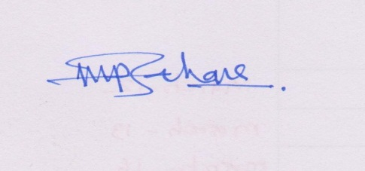 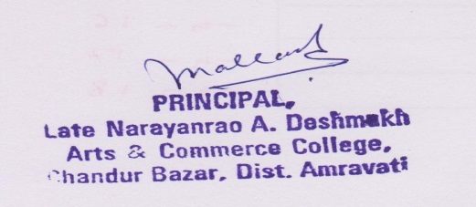 ______________________________ _______________________________*

*Signature of the Coordinator, IQAC Signature of the Chairperson, IQAC*

*_______***_______*

**List of Annexure**

1. **Annexure I: Academic Calendar of the year**
2. **Annexure II: Action Taken Report**
3. **Annexure III: Analysis of the Feedback**
4. **Annexure III: Two Best Practices of the Institution**

***Annexure- I***

**Academic Calendar 2013-14**

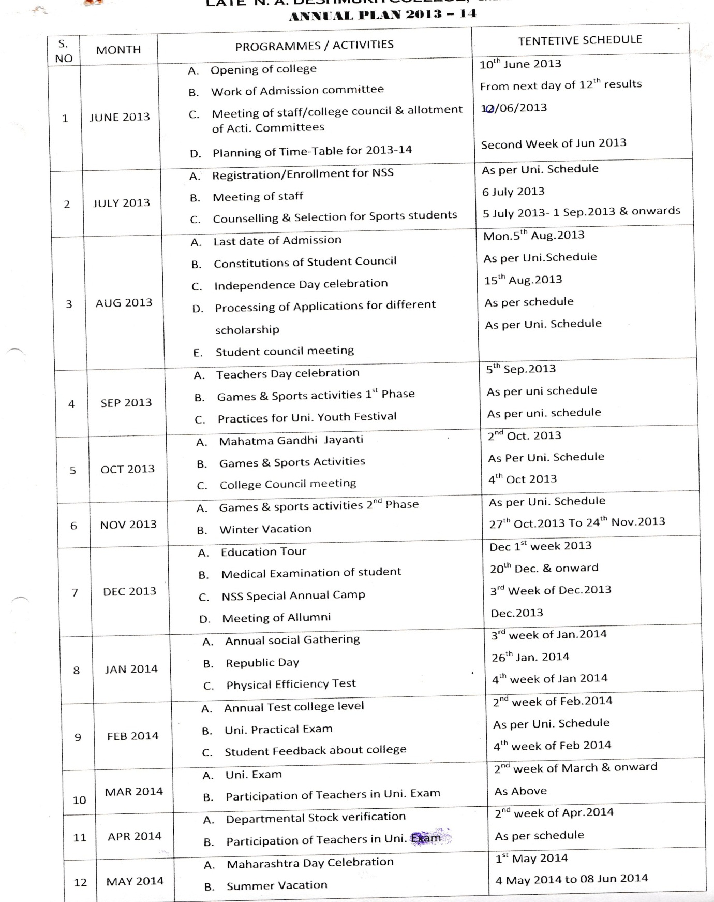

***Annexure-II***

**Action Taken Report**

(Based on Academic Calendar)

**Session 2013-14**

The working day starts on 10th June 2013 for the session 2013-14. After the declaration of HSSC result admission process was started. The meeting of College Council was held as per the academic calendar. In the month of second June annual planning was prepared. The activity schedule of NSS, games and sports was prepared and displayed. Schedule of the constitution of Students’ Council was displayed as per the directions by Sant Gadge Baba Amravati University Amravati. On 15th of August Independence Day was celebrated in the college. Guidance regarding scholarship was provided to the students admitted. Teacher’s day was celebrated on 5th of September. In the month of September students participated in youth festival organised by the university. A meeting of College Council was held on 4th October.

Educational Excursion was organised in the first week of December. Physical efficiency test was conducted from 20th December onwards. NSS Special Camp was organised in the third week of December. Alumni Association meet was held in the month of January 2014. In the second of February common test on the ground of University Examination was conducted. Practical Examinations were also held in the month of February. Feedback forms were taken from students in February. In the month of March University Examination was conducted. Stock and stock register was checked up in the month of April.

*****

***Annexure-III***

**Analysis of Feedback obtained from Students for 2013-14**

The continuous analysis of the teaching and learning process with the help of students’, parents’ and alumni’s feedback facilitates the teachers and the college to improve the knowledge, skills and the quality of the education. The college sought regarding teachers, college, the office staff, college campus, infrastructural facilities, college atmosphere and quality of teaching staff.

The feedback for the year 2013-14 was analysed and the observations have been stated below.

**Findings:**

* 80% of the students were of the opinion that the syllabus of each course was adequate and challenging.
* 78% of the students were of the opinion that the course was easy.
* 82% students were of the opinion that 100% of the syllabus was covered in the class.
* 82% students were of the opinion that the library material and facilities for the course are adequate.
* 100% students were of the opinion that the teacher was thoroughly prepared for the classes.
* 74% students were of the opinion that the teacher’s ability to communicate was always effective.
* 80% students were of the opinion that the teachers encourage student participation in the class.
* 74% students from all faculties were of the opinion that teachers are very helpful in advising them to generate interest in the subject.
* 78% students said that the teacher’s approach is always co-operative.
* 80% students from all faculties were of the opinion that internal assessment was always fair.
* 94% students were of the opinion that feedback on performance was provided regularly and with helpful comments.
* 86% parents were of the opinion that infrastructural facilities were adequate.
* 74% parents were of the opinion that they were satisfied with the progress of their wards.
* 68% parents were satisfied with the approach of teachers.
* 90% alumni were of the opinion that students should be promoted to participate in seminars and group discussions.
* 86% alumni were satisfied with facilities being provided to students.

********

***Annexure- IV***

Best Practices

1. **Alumni Association**

**Objective:**

Alumni Association is working so that the college could get useful suggestions to strengthen the quality of teaching. The status of administrative progress and infrastructural set up must be sought from alumni.

**The practice:**

One meeting of Association is organized in a year. In a meeting the Principal chairs and appeals all alumni to speak on the present status of the college. Every alumnus is given sufficient time to speak. After the meeting feedback forms are distributed and alumni are asked to fill them up. The filled feedback forms are collected and afterwards are analysed for taking their suggestions into consideration. For the session 2013-14, a meeting of Alumni Association was conducted on 31st January, 2014.

**Evidences of success:**

The college finds Alumni Association very useful. Alumni express themselves to full extent. They put their views on the education system. Their suggestions have been proved very useful in taking policy decisions. Feedback from them proved very useful.

*******

1. **Students’ Co-operative Consumer Store**

**Objective:**

To facilitate students regarding books and stationery is the motive of Students’ Co-operative Consumer Store. The store is run on co-operative basis.

**Practice:**

Useful books, notebooks, and other stationary are kept in the store for sale. The students of the college can buy stationery at reasonable cost from the store. The store is situated in the campus. Reprographic facility has also been made available for students in the store.

**Evidence of success:**

The students don’t need to go to the market for basic stationery since basic material is available with the store. Reprographic facility has been proved very useful for the students.

*\*\*\*\*\*\*\*\**